TECHNICAL MANUAL

METACENTRIC HEIGHT OF SHIP MODEL
AIM: Determination of Metacentric Height of a War Ship / Cargo Ship

INTRODUCTION:
For all floating bodies stability is of much importance. Stability means the tendency of a floating body return to its original up right position after it has been displaced. Any external force caused gets body displaced in floating condition. Any floating body should have stable equilibrium.
BRIEF THEORY:
The metacentric height is a measurement of the initial static stability of a floating body. It is calculated as the distance between the centre of gravity of a ship and its metacentre. A larger metacentric height implies greater initial stability against overturning. Metacentric height also has implication on the natural period of rolling of a hull, with very large metacentric heights being associated with shorter periods of roll which are uncomfortable for passengers. Hence, a sufficiently high but not excessively high metacentric height is considered ideal for passenger ships.

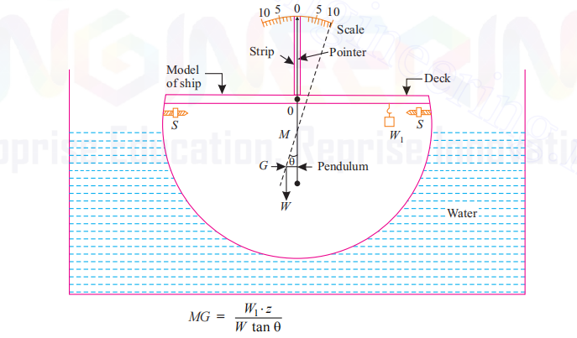

SPECIFICATIONS:

- M.S. tank or size 700 mm x 700 mm x 300 mm with drain valve.
- A hollow ship model with balancing weight.
- Circular weight 4 in numbers.
- A pendulum & graduated arc for measuring tilt angle
- Weight of ship model 7.800kg.

EQUIPMENT:
A small ship model having provision to put load on the deck or at base and an arrangement to measure the inclination due to loading.

EXPERIMENTAL PROCEDURE:
Place the ship in water tank and wait for sometime till the water becomes still. Confirm that pointer reads zero. If it is not reading zero adjust the side screws for initial zero.
Now put some weight say ‘W’ on any side of the top pins. The ship still tilt through angle ‘θ‘ which can be measured on scale.

Then the metacentric height = w × x

W tan θ
Where,
x = distance of weight from centre. w = additional load.
W = weight of the ship

OBSERVATION :
- Weight of ship = W = 7.800 kg
- Distance of pin from centre on deck = x = mm
- Additional weight on deck = w = kg.

Sr No. | W kg. | w = wt. added in kg. | θ = Angle of tilt
1.
2.
3.

w × x Metacentric Height = -------------------
W tanθ
Similar observations can be taken by putting additional weight at bottom of ship. In this case W = total weight of ship will be = W + W’ where W’ = weight added at base of ship, with weight at base the ship is called as cargo.

PRECAUTION:
Put load in such a way that ship does not sink below the marking on outer surface.

SERVICE REQUIRED :
- Suitable table to mount the equipment else can also be kept on ground level.
- Water supply to fill the tank.
- Floor space 1 mt x 1 mt.



